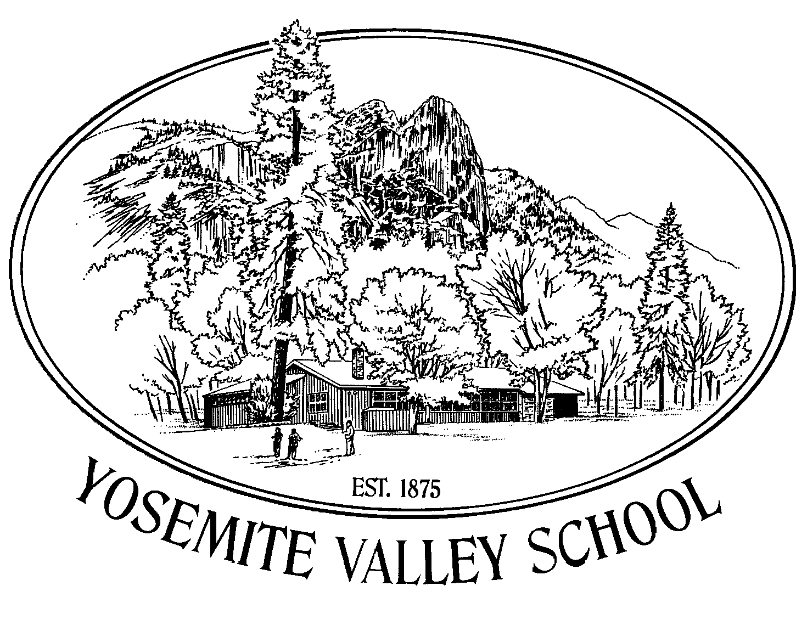

Yosemite National Park Valley School
Parent/Guardian/Student
School Handbook
2012-2013 School Year



Sean Jacobs, Principal
Aaron Rosander, Superintendent
Mariposa County Unified School District

Yosemite National Park Valley School
VISION AND MISSION STATEMENT
Our mission is to provide high quality educational experiences that meet the needs of all students, focusing on established academic standards, maximizing student potential and striving for individual academic excellence.
We envision Yosemite Valley School as a center for the development of environmental and cultural knowledge about the Yosemite region, where students learn to become responsible, accountable, and respectful citizens of the Earth. We see ourselves as partners in learning based on participation, appreciation, and contributions within the community and beyond. Students are encouraged to be creative and critical thinkers, problem solvers, and effective users of technology.

The Yosemite Valley School Staff

Sean Jacobs

Principal

sjacobs@mariposa.k12.ca.us

Ceci Archer
Secretary
carcher@mariposa.k12.ca.us

Tony Muñoz, Custodian

Cathy DeCecco
Lead Teacher, Kindergarten-2nd Grade
cdececco@mariposa.k12.ca.us

Peggy Lyle
Teacher, EOC, 3rd-4th Grades
plyle@mariposa.k12.ca.us

Patsy Fulhorst
Teacher, 5th -6th Grades
pfulhorst@mariposa.k12.ca.us

August, 2012

Yosemite Valley School Families:

It is with great pleasure that I write to welcome you and your student(s) to the 2012-2013 school year at Yosemite Valley Elementary. The faculty and staff have been busy preparing the school and classrooms for you and your students. As always, our number one goal will be providing our students with a quality educational experience focusing on academics, community, creativity and innovation. As the principal, I am looking forward to hearing about your wonderful summer, getting caught up with our returning families, and meeting our newest Badgers.

Wednesday, September 5th is Back-to-School Night. Please mark your calendars and book child-care for this important introduction to your child’s new grade level. Also, please note that important information about our programs, procedures and activities can be found in this handbook, which is updated annually, and also in the weekly Badger newsletter which will be updated every other Tuesday on our website http://yosemitevalleyschool.weebly.com. The Badger will include the most updated schedules and information.

Please feel free to call or email me. I look forward to meeting you all in person soon.

Sincerely,

Sean Jacobs
sjacobs@mariposa.k12.ca.us

PLEASE RETURN REQUIRED/REQUESTED FORMS AND SIGNATURES TO THE SCHOOL AS SOON AS POSSIBLE.

Signature pages are pink.

TABLE OF CONTENTS

School Vision and Mission Statements . . . . . . . . . . . . . . . . . . . . Inside cover
- Welcome letter . . . . . . . . . . . . . . . . . . . . . . . . . . . . . . . . . . . . . . . . . . . 1
- Table of Contents . . . . . . . . . . . . . . . . . . . . . . . . . . . . . . . . . . . . . . . . . 2
- A Brief History of Yosemite Valley School . . . . . . . . . . . . . . . . . 3
- School Hours and Calendar . . . . . . . . . . . . . . . . . . . . . . . . . . . . . . . 4
- General Information . . . . . . . . . . . . . . . . . . . . . . . . . . . . . . . . . . . . . . . 5
- Procedures and Responsibilities . . . . . . . . . . . . . . . . . . . . . . . . . . 6
- “When you have concerns” . . . . . . . . . . . . . . . . . . . . . . . . . . . . . . . . 8
- Standards of Behavior . . . . . . . . . . . . . . . . . . . . . . . . . . . . . . . . . . . . . 8
- Developing Good Study Habits at Home . . . . . . . . . . . . . . . . . . . 10
- APPENDIX . . . . . . . . . . . . . . . . . . . . . . . . . . . . . . . . . . . . . . . . . . . . . . . . 11
- Curriculum and Academic Standards . . . . . . . . . . . . . . . . . . . 12
  - Standards in Areas of Academic Content
  - Grade level promotion and Retention
  - Curriculum Content and Materials
  - Elementary Opportunity Classroom
  - Information Literacy & Technology
  - Assessing and Reporting Student Progress
- A List of Important Names and Phone Numbers . . . . . . . . . . 17
- SIGNATURE PAGES (blue):
  - MCUSD Policy on Hazing . . . . . . . . . . . . . . . . . . . . . . . . . 19
  - Permission to go Home for Lunch . . . . . . . . . . . . . . . 21
  - Receipt of YVS Handbook . . . . . . . . . . . . . . . . . . . . . . . . 21
  - Walking Field Trip Permission Form . . . . . . . . . . . . . 22

A BRIEF HISTORY OF THE YOSEMITE NATIONAL PARK VALLEY SCHOOL
The first public school in Yosemite Valley was organized by J.A. Chestnutwood over 130 years ago in July 1875. For the first week the students sat on a fallen log and on boxes under a large oak tree. There were no books at first, and the teacher wrote words for the lessons on a packing crate! The site was about a mile from Yosemite Falls, probably close to Indian Canyon.
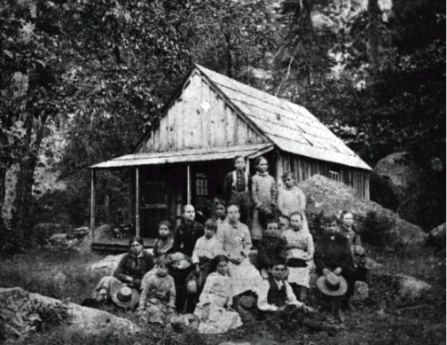This "fresh air" school was soon replaced by a 12 by 16 foot cloth structure with cedar uprights. A new building was then constructed on the south side of the Merced River, upstream from Sentinel Bridge. In 1910 the school moved to a site about 300 yards southwest of the National Park Service Headquarters. By 1918 there was yet another site, this one being close to our present location. The current building was completed in February 1956. Its most recent renovation took place during the summer of 1996. A few years ago, a new play structure was purchased for the school by the Yosemite Fund, and installed with a generous donation from the Yosemite Rotary Club. Park concessionaires (most recently the Delaware North Corporation Parks & Resorts at Yosemite) have contributed generously to the school over the years.
The school has been called many things over the years. In the year 2000, its name was formally changed to Yosemite National Park Valley School to distinguish it from the many, many “Yosemite” schools throughout California and officially designate its sole purpose for existence: to serve the children of Yosemite National Park employees.

TODAY AT YOSEMITE VALLEY SCHOOL
YVS, as the locals call her, is part of the Mariposa County Unified School District. Classrooms are equipped with computers, digital projectors, Interwrite tablets and internet access. Textbooks and classroom instruction are aligned with California’s academic standards. Our K-5th grade students benefit from regular work with the Spatial Temporal Math program. Yosemite Valley School has been recognized as a California Distinguished School multiple times. We have also been awarded the Service Learning Leader Schools Award for our continued focus on student-led service learning projects. And YVS continues to lead the pack of MCUSD schools with its Academic Performance Index scores. We are proud to staff three multi-graded classrooms to better serve our kindergarten through sixth grade span of children. Cooperative planning between parents and staff on the SITE Council based on data drives teaching initiatives aimed to increase student performance in all subject areas.
Our students have had international partnerships, based on environmental education projects, with schools in Japan and Scotland. To culminate a study of the origin of our park our students have visited the birthplace of John Muir, Dunbar, Scotland four times. Our Scottish friends have visited us in Yosemite, most recently this summer. We are proud of the school's long tradition in this “crown jewel” of a national park, which is now the destination of over four million visitors a year from around the world.

SCHOOL HOURS AND CALENDAR 2012-2013
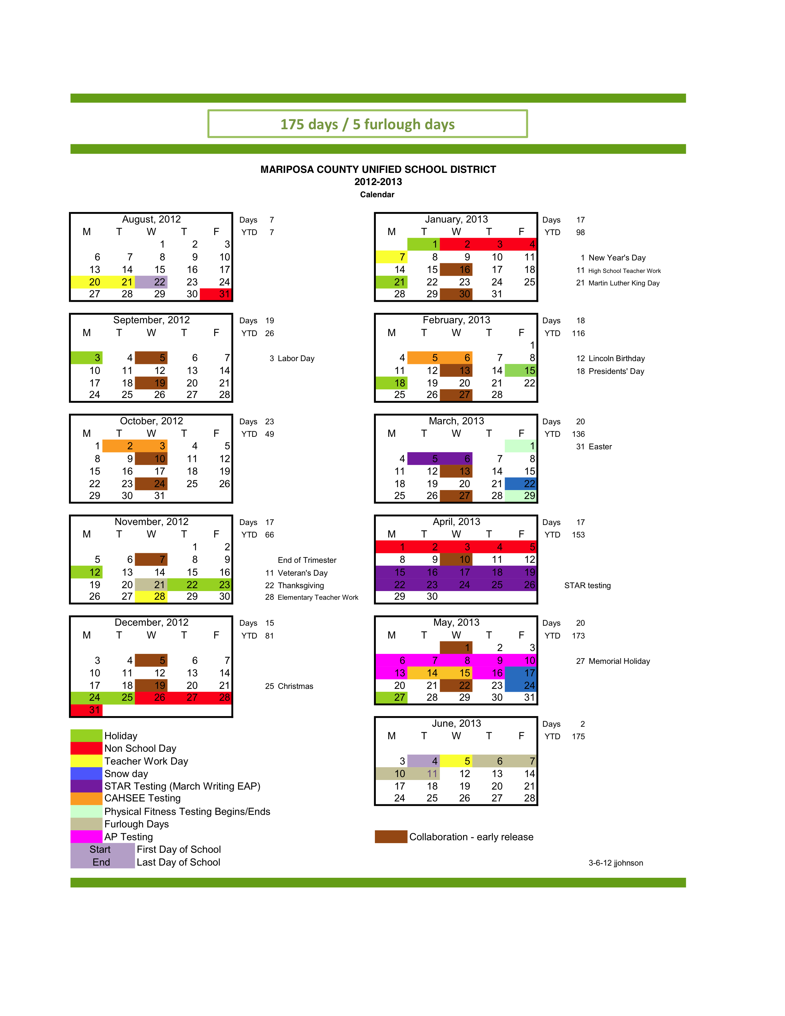

The MCUSD School Board meets the 3rd Thursday of each month @ 6:25pm.
Kirstie Dumbar-Kari is the Yosemite Area School Board Member (Kirstiekari@gmail.com)
Schedule for Regular School Days
arrive recess lunch dismissal
Kindergarten: 8:15 am 10:15-10:35 12:00-12:45 12:45
Grades 1-6: 8:15 am 10:15-10:35 12:00-12:45 2:30

Schedule for Minimum Days
arrive recess lunch dismissal
All students: 8:15 am 10:15-10:30 NONE 12:30

For the most current, updated information, read The Badger.

GENERAL INFORMATION

- School Hours & Contact. The school office is officially open from 7:45 a.m. to 2:00 p.m. Students may arrive as early as 8 a.m. The first class bell rings at 8:15 a.m. The school phone number is 209 372-4791; fax machine 209 372-8791. Your phone call may be answered by our new voice mail system. Please leave attendance messages in the General School Mailbox not the individual teachers’ mailboxes. Mailing address is P.O. Box 485, Yosemite National Park, CA 95389. Electronic mail addresses are listed on the inside of the front cover. At the end of the day students must check-in in person with caregivers before coming back to school to play.
- School & Classroom Visitations. Parents are encouraged to visit the school anytime. All visitors (including parents) are required to sign in at the office before entering any classroom. (The sign-in sheet is located on the office desk.) Courtesy suggests you call ahead to arrange a classroom visit. Student guests (such as a visiting friend) are discouraged and must obtain prior permission from the principal to be on campus.
- Student Council. Yosemite Valley School has an active Student Council and students are encouraged to get involved. The Student Council organizes many exciting student events. Student elections take place about 3 weeks after school starts.
- Ski Program. All students have the opportunity to learn to ski in a winter program sponsored by DNC and the Yosemite communities. Wednesdays between January and Spring Break will be set aside for this activity. For a small fee, students are transported to Badger Pass, fitted with equipment, and given ski lessons. Kindergartners and first graders must be accompanied by an adult in order to participate. This is our most volunteer reliant program… without volunteers we cannot ski.
- Parent Involvement Groups. The Parent Teacher Group is mainly a fundraising vehicle for supporting students and staff at YVS, and as such those involved have a real say in the “direction” of our school. The PTG meets monthly. SITE Council is a school based decision-making group that deals mostly with District related categorical funding and the overall school “vision”. SITE may meet only 2-5 times per year.
PROCEDURES AND RESPONSIBILITIES

- Children who miss school miss out! Did you know that the majority of our classroom learning is done without worksheets and papers? We do work aloud, on dry erase boards, with pocket charts, and in journals that stay at school. When a student is absent those kinds of activities cannot be sent home to make up. State law requires attendance in a full-time school program and thus bases funding on our school’s Average Daily Attendance. Absences may be excused only for: (1) personal illness or injury, (2) medical or dental appointments that can’t be made outside the school hours, and (3) attendance at the funeral of an immediate family member, as described in the packet you received from the Superintendent. MCUSD promotion policy states that positive attendance (of at least 90% per grading period) is an indicator of academic achievement when determining grade level promotion. Unexcused absences, an unusually high number of excused absences, or a pattern of tardies are reported to the School Attendance Review Board.
- When your child must be absent or late…. It is your responsibility to phone the school prior to 9:00 a.m. This policy is made for the safety of your child. Please don’t forget to call! (372-4791) Students are responsible for promptly completing any make-up work.
- Homework. Homework is important and intended to be an extension of learning. Requirements and specific procedures are determined by each teacher. However, in general YVS students are asked to read and/or be read to, and to practice basic math skills at least four nights per week.
- Independent Study Program. We discourage personal obligations which take students away from school because it is difficult to make up the valuable instructional time and activities presented in the classroom. However, we recognize that there are times when students must be absent for personal reasons over a period of time. Should you anticipate an absence of five days or longer, please request an Independent Study contract from your child's teacher at least 48 hours in advance. You may call the office with this request or send a note. Independent study contracts are not available for less than five consecutive days and must be signed by parent/guardian prior to the anticipated absence. Independent study assignments must be completed by the student while absent and turned in the morning the student returns to school. Incomplete Independent Study contracts are treated as unexcused absences. (Call the office for more information.)
- Medications. Prescription or over-the-counter medicines, must be accompanied by written instructions signed by a parent or physician. All medication must be kept in the school office and dispensed by an adult. Students who have a condition requiring daily, on-going administration of medication must have written instructions, signed by the physician and parent, on file in the school office. Medications must be updated at the beginning of each school year. The school does not keep any over-the-counter medications on site and school personnel are prohibited from administering any other medicine, including aspirin and calamine lotion.
- Reporting Responsibilities. School employees are mandated by law (PC§11166) to report cases of suspected child abuse or neglect (either physical or emotional). All employees have attended training sessions to enhance their knowledge and awareness of this subject. Additionally, Education Code §48900.2 requires enforcement of the District's sexual-harassment policy.
- Music. There will be a district funded music program for the 2012-13 school year.
- Library. Students are given regular opportunities to check out books and other materials from the school library. It is important that these materials be kept in good condition and returned to the library by the due date. The library is open during school hours.
- After school activities. All students must check in with their parent or designated caregiver upon dismissal from school before they may return to school grounds for non-school activities. To avoid interference with instruction of older students we ask that parents please refrain from using the school grounds until after the 2:30 afternoon dismissal. Students wishing to stay for an adult-supervised, organized activity should have evidence of parent permission to do so. Students are expected to conduct themselves appropriately and follow school behavior rules whenever they are involved in activities on school property. YVS staff does not supervise activities that are not school-sponsored/organized.
- Leaving Campus. YVS is not an open campus. Only students with parental permission to leave campus (form included with this handbook) may leave school grounds during the lunch period, and only to go home for lunch. THIS IS NOT PERMISSION TO GO TO THE VILLAGE DURING THE LUNCH HOUR. For safety reasons, once students return to campus during lunchtime, they will not be allowed to leave again. Otherwise, students must be signed-out by authorized persons in order to leave campus during the school day. Only authorized persons (those listed on your child's emergency card) will be allowed to take your child from school. Please keep emergency cards up to date. If you need someone not listed on the emergency card to take your child from school, you must send a signed, dated note so stating.
- Volunteers. We love volunteers. However, becoming a volunteer is no longer as easy as it used to be. State law requires that all school volunteers be fingerprinted and show proof of a clear tuberculosis test. If you anticipate volunteering at the school, please contact the office to begin the process of clearance. Paperwork for fingerprinting and information about TB testing can also be obtained at the District office (742-0250). Volunteers may not perform duties that expose them to confidential information. Parents who volunteer on field trips where they agree to drive students in their cars and/or stay overnight with students must go through the volunteer process. We regret that times are such that we need to do this in the best interest of our children.
- Weekly Progress Reports. Teachers will prepare progress reports that indicate areas of strength, work that has not been completed or areas of concern. At any time during the school year parents who need more information should contact the teacher for a conference.
- Conferences. At YVS, fall student-led conferences are held after the sixth week of school. By this time students have created their own goals and teachers have become familiar with each student’s strengths and can make suggestions for areas of improvement. At this first conference parents can also express the goals they have for their children thus creating a solid network of communication that addresses each individual child. Teachers will contact parents for additional conferences when needed during the remainder of the school year. Parents are invited to ask for conferences at any time during the school year when they would like more information about their child’s progress.

When you have concerns
First: Talk with your child—try to find out what's really going on. Sometimes children will have difficulty explaining the source of the problem. Keep communication open so your child will feel comfortable discussing his/her feelings and concerns with you.
Then: Talk with your child's teacher. Calling for an appointment is much better than popping in before or after school. This allows teachers to make adequate time for meaningful discussion.
Finally: Please contact the principal if you want further discussion.

STANDARDS OF BEHAVIOR

Our goal at Yosemite Valley School is to provide a safe, positive and supportive instructional environment to enable students to achieve their educational goals. We set high expectations for student behavior to ensure that we provide the best opportunities to learn.
Students who exhibit inappropriate and/or dangerous behavior are subject to disciplinary action including on-campus suspension, off-campus suspension and referral for expulsion.
The Mariposa County Unified School District Standards of Behavior Guidelines provides detailed information on the behavior standards and discipline policies used at Yosemite Valley School. Please read this handbook and keep it on hand to serve as a guide for success at our school. Additional copies of the handbook are available in the principal’s office.

At Yosemite Valley School, students are part of a school-wide community of learners and are expected to be…
- trustworthy
- respectful
- fair
- caring
- responsible
General Rules for Students
1. Follow adult instructions.
2. Treat others as you would like to be treated.
3. Use appropriate language and “tone”.
4. Be respectful to everyone.
5. Follow classroom rules.

- and good citizens

Important Playground Rules
- All games are open to whoever wants to play.
- Equipment should be used properly.
- Everyone should play fairly.
- All should care for the safety of others as well as of themselves.

Important Lunchtime Rules
- Students are to stay seated while eating until lunchtime supervisor indicates eating time is up. Students may continue eating if they need more time.
- Students are responsible for their own trash and should recycle what can be recycled.
- Students are expected to use appropriate manners while eating.
- Students are not to “trade” or give-away their food.
- Only students with parent permission may leave campus in order to go home for lunch and once they have returned to campus they may not leave again.

There is a sequence of consequences when students choose not to follow school rules:
First there is a verbal warning – unless the behavior involves serious defiance or physical altercation, in which case home contact and possible suspension may take place, without warning.
Repeated offenses may result in …
- Sitting-out of an activity (including recess), and/or teacher-student conference
- Teacher-student conference and entry made in student records.
- Conference with principal or designee, home contact, and entry in student records.
- Conference with principal or designee and at-school meeting with parent/or suspension, depending on the offense.
- Individualized behavior plan.

Students are also expected to follow rules of safety and conduct (including dress code) set forth by the MCUSD Board of Education. See the district booklet that accompanies this handbook for information about the following subjects and more:
- Attendance
- Discipline
- Dress and Grooming
- zero tolerance policy
- student use of technology
- health services
- kindergarten oral health assessment
- pupil records
- Due process and complaints
- sexual harrassment

Developing Good Study Habits at Home
Children need to develop good study habits in order to be successful at school. We suggest establishing a regular time each day for homework and study, allowing time just after school to play. Just before or after dinner may be the best time for homework.
Ways parents can help:
- Try to keep homework time pleasant. Homework should be an opportunity to practice skills or concepts being taught at school. If homework becomes a struggle, if they don’t understand what they are to do, students should bring it back to their teacher for further instruction. However, students should read for 30 minutes every night and practice basic math facts until they are memorized.
- Establish a routine for homework. That means a regular time and place where homework can be completed. When a child knows he/she will put in the time regardless of how much homework there is, he/she is more likely to learn to be thorough. Keep distractions to a minimum. This includes television and radio, siblings, and telephone calls.
- Regardless of what other homework a student has, reading at home is required at all grade levels. Research tells us that the more students read, the better readers they become. Fluency, word recognition and vocabulary are developed as a child reads. Reading at home or other places (away from school) is so very important to reading progress. Lap reading with younger children is an essential part of reading preparation for children.
- Regardless of what other homework a student has, memorization of math facts is required. Students should know their addition facts by end of grade 2 and multiplication facts by end of grade 3. It is almost impossible for a student to rely on the classroom alone to learn math facts. We really need parents to help with this skill.
- When students finish work, parents should check it for neatness and obvious mistakes. However, parents are expected to be supportive and not overly critical. Talk to the teacher if you are not pleased with your child’s quality of work.
- Help your child to understand that he/she is responsible for his or her own actions and behavior.
- Expect your child to grow toward independence, by offering challenging opportunities. Children also need limits within which to function, and directions as to how to respond.
- Please, get both (or all) sides of the story before drawing conclusions. In case of a misunderstanding, contact the school.
- Remember that teachers have many children to care for and need all the data you have about your child to be effective in providing the right kind of program. Any circumstances which may affect the child's education (including health problems) should be shared with the school.
- Remind yourself that teachers usually teach because they care about children, that their objectives and yours are usually the same, and that agreement on how to achieve the objectives requires good two-way communication.
- Spend a few minutes with your child every night to check on his or her homework and talk about school. Don’t accept “nothing” in response to “What did you do/learn in school today?” And Don’t accept “nothing” in response to “What do you have for homework?” (see items 3 and 4 above)
- Don’t forget your homework –
LOOK UP THE ONLINE BADGER EVERY TUESDAY!

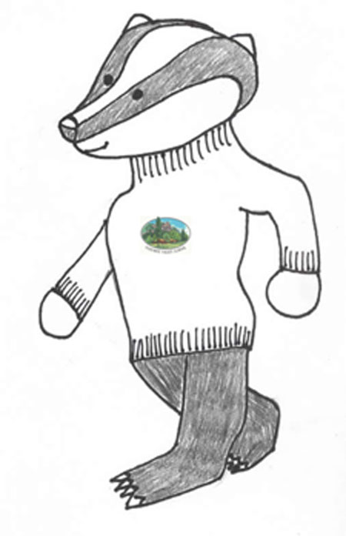

Curriculum and Academic Standards…. pg. 12
List of Important Names & Phone Numbers …. pg. 17
SIGNATURE PAGES:
MCUSD Policy on Hazing …. pg. 19
Permission to Go Home for Lunch …. pg. 21
Receipt of YVS Handbook …. pg. 21
Walking Field Trip Permission Form …. pg. 22

JUST IN CASE YOU MISSED ALL THE OTHER “HINTS”…
Our home newsletter, The Badger, is published every other Tuesday. Don’t forget to read it!
http://yosemitevalleyschool.weebly.com
Please let us know asap if you do not have internet access.

CURRICULUM AND ACADEMIC STANDARDS

- Standards in Areas of Academic Content. Mariposa County Unified School District has adopted the California State Academic Standards. All standards at every grade level can be viewed on the worldwide web at http://www.cde.ca.gov via the link “Standards & Frameworks”. Furthermore, parents may request copies of their child’s grade-level standards from the school at any time. Copies of Standards Publications are also available to borrow from the school library and from the Park branch of the County Library.
- Grade level promotion and Retention. MCUSD has established minimum academic standards (called Promotion Standards) in which students must display competence in order to be promoted to the next grade level. Promotion standards for each grade level are provided to parents by their child’s teacher (at Back-To-School-Night). Students who are deemed to be at risk of not attaining required levels of competence in these minimum standards will be identified early; parents and students will be formally notified, and intervention plans will be made. Progress toward promotion is based on demonstrated growth in learning and upon attainment of district grade-level standards.
Indicators of academic achievement include, but are not limited to:
- Standards-based student work assessed by designated benchmarks in language arts and mathematics for the appropriate grade level and collected in a portfolio;
- Student grades or “rubric” ratings in designated core curriculum areas;
- Scores on district, teacher, and/or publisher developed tests and assessment tools that are aligned with the content standards;
- Teacher observations of student work;
- Positive classroom attendance of at least 90% per grading period. Positive attendance shall include independent study (minimum of five days per contract).

- Curriculum Content and Materials. California students must receive instruction based on the California State Standards. The text books and materials adopted by Mariposa County Unified School District are aligned with the state standards. Teachers use their professional skills to seek our methods and materials designed to engage students in a multi-graded learning situation that will be help them master these standards.
- Reading. Learning to read is the most important skill that students develop during their early academic years. After grade three, students leave the “learning to read” stage and enter the “reading to learn” stage. The stages of “learning to read” and “reading to learn” help establish a further stage that extends through grade eight. That stage is perhaps best characterized as reading and learning for life, during which students begin to grapple with the full and complex range of lifelong language and literacy skills.* Students learn to decode words and to read basic sight words in the primary grades. At all grade levels students work on increasing vocabulary and comprehension skills through reading. Students read aloud and are read to by their teacher, to develop fluency and vocabulary. They are involved in instructional discussion about what they read. Reading homework is important, is assigned each day and is encouraged over weekends and holidays. Students may be assigned something to read or they may read books at the independent level for enjoyment. The important thing is that they read each day after school. Individual reading development is assessed through teacher observations of student progress, reading inventories and fluency scores.
- Math. Mathematics is as important as oral and written language in the communication of ideas.* Our district has adopted the K-6 math program from Houghton-Mifflin Publishers and the curriculum is aligned with California standards. Math is applied in other curriculum areas (especially science) and student projects whenever possible. Students who have not memorized all basic math facts to automaticity have math homework each night; they need to practice after school each day. Addition/subtraction facts should be memorized by the end of second grade, and multiplication facts by the end of third. Individual math development is assessed through teacher observations of student progress and textbook assessments. The Spatial Temporal Math program is in place for K-5th grades and is designed to cement important math concepts through visual “games.” Students are expected to spend 45 minutes in K-1 and 90 minutes in 2nd-5th on the program each week during school time.
- Writing Strategies and Applications. The systematic progression of writing instruction and application in the primary grades prepares students to write clear and coherent sentences and paragraphs, with a clear purpose and sense of audience. At all grade levels, teachers use direct instruction to teach specific developmental skills in writing and use a “Writer’s Workshop” multi-grade level approach and “Step Up To Writing,” that emphasize planning and revising for clarity. The California Department of Education has defined grade level standards:
- By the end of third grade students should be writing formal letters, narratives and descriptions in paragraph form and understand that the process of writing includes revision and editing.
- By the end of fourth grade, students should progress to writing multiple paragraphs. Their curriculum includes the addition of report writing and summaries.
- By the end of grade five more genres are added: response to literature, research reports, and persuasive writing.
- By the end of the middle grades students are also expected to be able to write expository compositions, technical documents, and documents related to career development, in addition to grade level appropriate writing of prior genres
At each grade level, writing is assessed according to state designed scoring guides. Samples are collected for each student to document progress as a writer. Students in grades 3-6 have access to keyboarding practice and use of computers for writing. At times teachers will require that students present final writing products in their best printing or cursive, or as a word-processing document. In any case, teachers will not accept “sloppy” work. Students in 4th grades must demonstrate writing proficiency on a state assessment in March. A district assessment of all other grade levels is done on the same day.
- Written Language Conventions: Spelling, Grammar, Punctuation and Capitalization. The California Department of Education has defined standards at each grade level to address the conventions of writing. They concern the knowledge of sentence structure, English grammar, how to use punctuation correctly, capitalization and spelling.
- By the end of grade two students are expected to know the difference between complete and incomplete simple sentences and be able to identify and use nouns and verbs, contractions and possessives, commas, quotation marks and sentence end marks. They should be capitalizing the first word in a sentence and in proper nouns, and spell high frequency words and short and long vowel, r-controlled and consonant blend patterned words.
To those basic skills, more expectations are added at each grade level, including (for example):
- Third graders learn to alphabetize.
- Fourth graders learn to use parentheses and understand word roots, prefixes and suffixes.
- By the end of sixth grade, students can also correctly identify and use prepositional, dependent clauses and colons.
Student assessment of these skills includes spelling tests, teacher assigned writing and consideration of writing across academic disciplines.
- History/Social Studies: According to the California History/ Social Science Framework: Students should “study history not to register high scores in trivia contests, but to learn from the sometimes painful, sometimes exhilarating, often humdrum experiences of those who preceded us; …[studying] major historical events in depth as opposed to superficial skimming of enormous amounts of material.” In order to ensure depth of understanding instead of superficial coverage, it is common practice in multi-grade classroom situations to teach subjects out of grade level sequence, rotating content over. Standards found in this subject area can often be integrated with other content areas (for example Science and Language Arts) and covered through a thematic approach. Third grade standards address connections with the past and the way local, state and national government and traditions have developed, with an emphasis on California physical and cultural landscape, including the study of American Indians; while fourth grade standards focus on California. Fifth grade standards focus on different periods of American history. Sixth grade standards focus on different periods in world history.
- Science. California content standards at each grade level cover topics in physical, earth and life sciences. All students need to develop a good sense of the scientific process, which is based on understanding how observing leads to questions about which predictions (hypotheses) are made. Investigations provide data about the predictions, which can be evaluated and then communicated to other scientists for verification or discussion. Throughout the k-6th grade years these strands of life, earth and physical science are woven through the CA State Standards and they provide the themes for teaching science with a project oriented approach in the multi-graded classroom. New district adopted teaching materials, FOSS Kits, will provide the students with cohesive units of study that cover all pertinent state standards for science. Yosemite National Park provides a natural starting place for scientific research and many people in the field upon whom we can draw for expertise on a variety of scientific topics.
- The Arts. While academic standards have been published for the visual and performance arts and “studies show that pupils of the arts outperform their non-arts educated peers on measures of academic achievement,” art education is not adequately funded in California.
- Visual Arts: Visual Arts standards involve artistic perception, creative expression, historical and cultural context, and aesthetic valuing. Practice in the visual arts enhances skills in spatial organization, orientation, categorization, as well as aesthetics. Art work is integrated into other curriculum areas (for example, literature and science lab reports) to enhance learning.
- Performing Arts: Students participate in formal performances such as The Winter Performance and Dogwood Festival (celebrating Spring). In addition to being entertaining, these performances help YVS students master California Standards in oral language, reading, performing arts, and often social studies.
- Physical Education. Education Code 51223 requires that physical education in an elementary school maintaining any of grades 1 to 6 shall be for a total period of time of not less than 200 minutes each 10 school days. All students are expected to fully participate unless they have a note from their parent/guardian or doctor (please specify the nature of the problem) as an adaptive program may be in order. Appropriate shoes are required. Students will be engaged in at least 20 minutes of aerobic, physical fitness, skills building and other activities that keep all students active and engaged. Students are encouraged to get involved in the various sports and other physical activities offered outside of school, such as skiing, ice skating, dance, gymnastics, soccer, softball, swimming, hiking, biking, and basketball. Students are tested for physical fitness state-wide in 5th grade.
- Elementary Opportunity Classroom: Students may receive extra help when assigned to the EOC at Yosemite School. Students in EOC are required to keep up with regular classroom assignments, but are provided one-on-one assistance, help in organizational skills, and an extra quiet environment when needed.
- Informational Literacy and Technology. Yosemite Valley School is committed to preparing learners to work in an information age and economy by encouraging students to be creative and critical thinkers, problem solvers, and effective users of technology. The schools attended by our students’ parents were developed to meet the needs of an industrial age of our country’s evolution. We are no longer in the industrial age. The information available to our students (and to the American public in general) is overwhelming. Our task as educators is to help our students learn how to access and organize all that information in a meaningful way. In the age of information, two types of understanding are required in order to become productive adults: actual knowledge (facts and skills) and even more important, how to find the information you need. We believe that the use of technology should be as a tool to improve or enhance learning.
- The World Wide Web. Student access to the Web requires student and parent signatures on the district’s “Internet Acceptable Use Policy”. Parents may wish to stay in touch at the state level by logging on to: http://www.cde.ca.gov where the state’s academic standards publications, curriculum frameworks, laws and regulations, etc. can be accessed.
- Computer Access. There are student computers with internet access in every classroom. By third grade, students are learning keyboarding skills and how to store their work in files on our network server, where each student has a folder. Students are encouraged to use the computer and technology as tools. Other academic tools and motivators include the online math program, ST or V Math, and the Accelerated Reading program.
- Multimedia. Multimedia projects provide students with valuable experiences in problem solving, summarizing, and skills application as students organize information and prepare it for presentation. New equipment such as digital video cameras, Interwrite Tablets, and digital projectors enhance our multimedia repertoire.
- Assessing and Reporting Student Progress. Assessment goes beyond standardized state tests. At YVS we continually look at assessment data to guide instruction and planning. Multiple methods are used to assess student progress toward mastery of identified promotion standards, and assessment is on-going. We believe the purpose of assessment is not to weed-out who can and cannot, but rather to guide instruction and target assistance to those who need it. Therefore, interim grades may not have the same “weight” as the evaluation of a final project or activity in determining mastery. Standards that have been identified as prerequisites to success on the California High School Exit Exam (CHSEE) have been targeted by the district as promotion standards.

Assessment is on-going and performed through a variety of methods, such as:
- Use of standards-based, teacher-developed scoring guides.
- Teacher anecdotal records, interviews and observations.
- District criterion-based benchmark assessments.
- Criterion-based performance, activity or project.

Student progress is reported in the following ways:
- Weekly progress reports from teachers
- Report cards and interim classroom reports from teachers
- Parent-teacher conferences
- Projects, performances and Exhibit Day culmination, which parents can see
- Results of the California Standards Test (CST).

A List of Important Names and Phone Numbers

Principals have the primary responsibility for individual schools. If your question concerns our school, please direct it to the principal.

- Sean Jacobs, Yosemite Valley School 372-4791 or 379-2382 (El Portal); sjacobs@mariposa.k12.ca.us P.O. Box 485, Yosemite Valley 95389
Our School superintendent has the overall responsibility for the entire school system. If your question concerns the school district, it should probably go to the superintendent.
- Aaron Rosander, Mariposa County Unified School District, P.O. Box 8, Mariposa 95338, Phone: 742-0250
Email at: Arosander@mariposa.k12.ca.us

Our School Board decides everything from the size of our classes to our teacher’s salaries. Board members in our district are elected. Here are their names and email addresses.

- District 1-Representing the Yosemite Region: Kirstie Dumbar-Kari, kirstiekari@gmail.com
- District 2: Eldon Henderson, eldon.henderson@gmail.com
- District 3: Judy Eppler, jeppler@mariposa.k12.ca.us
- District 4: Joe Cardoso, jcardoso@sti.net
- District 5: Kimberly Forsythe-Allison, kallison@sti.net

School-based decision-making committee (School Site Council)
Our school Site Council, made up of half parents and half staff, has a say in the decisions that affect our school. Although they are an elected group, there is rarely an election, please contact the office if you are interested in serving. SITE Council board members will be chosen at the beginning of the school year.
Parent-Teacher Group (PTG)
Our PTG is a fundraising and general support group. Your 2012-2013 PTG Board Members are:
- President: Stephanie Hance
- Vice President: Position Open
- Secretary: Peggy Lyle
- Treasurer: Ceci Archer

Online Information
The Mariposa County Unified School District maintains a website filled with useful information located at: www.mariposa.k12.ca.us

Yosemite Valley School maintains a website with school information including weekly Badgers and student picture galleries at: http://yosemitevalleyschool.weebly.com

MCUSD Policy on Hazing

The Mariposa County Unified School District Governing Board and Spring Hill High School, Mariposa County Opportunity High School, Elementary Opportunity, and Mariposa Independent Learning School have established the following policies regarding “Hazing” as defined in Education Code

SECTION 32050-32051as follows:
32050. As used in this article, "hazing" includes any method of initiation or pre-initiation into a student organization or student body or any pastime or amusement engaged in with respect to these organizations which causes, or is likely to cause, bodily danger, physical harm, or personal degradation or disgrace resulting in physical or mental harm, to any pupil or other person attending any school, community college, college, university, or other educational institution in this state. The term "hazing" does not include customary athletic events or other similar contests or competitions.
32051. No student, or other person in attendance at any public, private, parochial, or military school, community college, college, or other educational institution, shall conspire to engage in hazing, participate in hazing, or commit any act that causes or is likely to cause bodily danger, physical harm, or personal degradation or disgrace resulting in physical or mental harm to any fellow student or person attending the institution.
The violation of this section is a misdemeanor, punishable by a fine of not less than one hundred dollars ($100), nor more than five thousand dollars ($5,000), or imprisonment in the county jail for not more than one year, or both.

Pursuant to Education Code 48900 (q), a student may be suspended or expelled for
Engaging in, or attempting to engage in, hazing as defined in Section 32050.
This violation is listed as 48900(q) on the Mariposa County Unified School District
Notification of Suspension.

Please familiarize yourself with this term and definition.

Student Signature_______________________________________________Date____________

Student Signature_______________________________________________Date____________

Student Signature_______________________________________________Date____________

Parent Signature________________________________________________Date____________

Yosemite Valley School

PERMISSION TO GO HOME FOR LUNCH

I give my child (student's name)_____________________________________ permission to walk home during the lunch period from 12-12:40 during the 2012-2013 school year. I understand that once students return to campus after leaving for lunch they will not be allowed to leave again during the lunch period.

Signed: ________________________________ (parent/guardian) Date: ___________

*Note: this is not permission to walk to the Village to buy lunch or to go to a friend’s house for lunch.

Yosemite Valley School
WALKING FIELD TRIP PERMISSION FORM – other side of page
Sometimes students learn outside the classroom. From time to time our teachers take walking excursions to various areas around our school. Sometimes an occasion presents itself at the spur of a moment that we don’t want students to miss. We enjoy being able to take students to places within the Park by walking or shuttle bus drive at such times. By signing the following permission slip, giving us permission to take students out within the valley, we will be able to take advantage of situations when we do not have time to give parents prior notification of these special events. In every instance, we will notify the office of our destination, so that you can get in touch with us in an emergency. Other field trips will be announced ahead of time and proper permission slips will be sent home

RECEIPT OF YVS HANDBOOK

Your signatures below indicate that you have received the Yosemite Valley School Parent/Guardian Student Handbook for the 2011-2012 School Year. We hope you have taken the time to read through it and discussed appropriate information with your child. If you have any questions about any part of the Handbook, or feel information is missing, please let us know.

I, the parent/guardian of ____________________________________________________ (student), have received and have or will review the Yosemite Valley School Parent/ Guardian Student Handbook for the 2012-2013 School Year.

Signed _____________________________________________________________ Date ___________

&

I am a student of Yosemite Valley School and understand the rules and expectations as outlined in the Parent/Guardian Student Handbook for the 2012-2013 School Year.

Student signature _____________________________Date __________

MARIPOSA COUNTY UNIFIED SCHOOL DISTRICT
STUDENT FIELD TRIP AND EMERGENCY MEDICAL AUTHORIZATION

Field Trip/Voluntary Activity Information
School Site:  Yosemite Valley School | Teacher / Advisor:  Cathy DeCecco, Patsy Fulhorst, Peg Lyle, Sean Jacobs
Date of Field Trip:  2012-2013 school year | Departure Time: Many of these activities are short in duration  Return Time: and scheduled quickly, according to weather  and opportunity.
Trip Destination (Name, City):  Local – Yosemite Valley | Purpose of Field Trip:  To take advantage of local learning experiences outside of the classroom.
TRANSPORTATION PROVIDED BY:   District School Bus   District Vehicle   Commercial Transportation |  Private Vehicle – supplemental permission form required  X Walking and/or shuttle bus   Other _________________________________

PLEASE TAKE NOTICE: California law provides that “All persons making the field trip or excursion shall be deemed to have waived all claims against the District or the State of California for injury, accident, illness, or death occurring during or by reason of the field trip or excursion. All adults taking out-of-state field trips or excursions and all parents or guardians of pupils taking out-of-state field trips or excursions shall sign a statement waiving all claims.” (Education Code section 35330.)

Parent/Guardian Authorization
I hereby release, waive, discharge, indemnify and hold harmless the Mariposa County Unified School District (MCUSD), its officers, employees, board members, and agents from all liability for any loss, damage, accident, injury, illness or death to my son/daughter/ward related in any way to participation in this field trip or excursion. Understanding this, I am signing this Agreement freely and voluntarily.

Field Trip Emergency Information / Authorization
In the event of an accident or other emergency when a parent/guardian is unavailable, I hereby authorize a representative of MCUSD to make such arrangements as he/she considers necessary for my child to receive medical or hospital care, including necessary transportation. Under such circumstances, I further authorize the treating emergency medical staff and/or licensed physician or surgeon to undertake such care and treatment of my child as he/she considers necessary. I understand that I am solely responsible to pay all costs incurred as a result of this emergency authorization.
I, the undersigned, have read this document in its entirety and I voluntarily sign my name on my and my child/ward’s behalf as evidence of my acceptance of the above provisions and participation in the program.

Name of Student

Printed Name of Parent/Guardian | Signature of Parent/Guardian  _______________________________________________ | Date  ________________________
Home Phone | Cell Phone and/or Work Phone | Other Emergency Phone

* From California Department of Education frameworks in Mathematics and Reading/Language Arts.

